AI-POWERED MEDICAL LAB REPORT ANALYSIS AND HEALTH INSIGHTS PLATFORM
Methodology, Novelty and Key Contributions
Department of Computer Science and Engineering, TKR College of Engineering and Technology (Autonomous)
Batch A8 (CSE-A) · Academic year 2026-2027
Table 1: Project team
S.No. | Student name | Roll number
1 | BANOTH SWAPNA | 23K91A0528
2 | BEKKAM VARSHITHA | 23K91A0535
3 | A NAVADEEP REDDY | 23K91A0502
4 | BUDIGAM MANOJ | 23K91A0546

Project guide: L.G REDDY
Chapter and section numbers quoted in the text (for example Section 6.6 or Chapter 8) refer to the full project report, 17.Final Document. Figures and tables in this document are numbered from 1.

1. OVERVIEW OF THE METHODOLOGY
This document describes how the system works from end to end and what is new in it. Part 1 gives the pipeline, the data, the algorithms and the reasons they were chosen; Part 2 sets the work against the base paper and separates what is new from what is standard; Part 3 lists the contributions.

6.1 Overall methodology
LabLens is a pipeline of deterministic stages, not a trained model. A report file enters, text comes out of it, the text is parsed into rows, each row is compared with its own reference range, and a plain-language note is attached to every abnormal row. No stage learns from data: the only fitted object is the term-weighting of a 55-name dictionary, computed when the module is loaded. This keeps every decision inspectable (a row is flagged because a number is outside a printed range) and keeps the whole system runnable on a laptop without a GPU or a download of model weights.
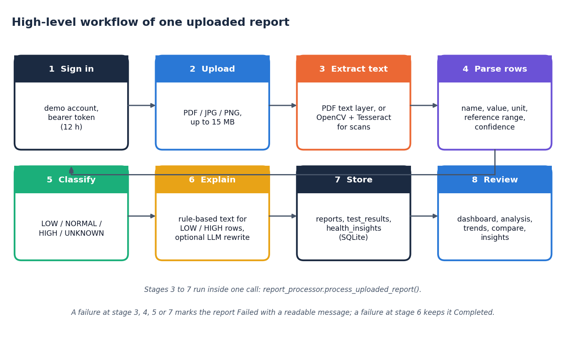
Figure 1: Overall workflow of the LabLens pipeline
1. Validate the upload: extension in {pdf, jpg, jpeg, png}, not empty, at most 15 MB (ocr_processor.validate_file).
2. Extract text: the PDF text layer for digital reports; OpenCV preprocessing and Tesseract for scanned pages and photographs.
3. Parse rows: a line-level regular-expression parser finds the name, value, unit and reference range of each result.
4. Normalise names: a TF-IDF character n-gram matcher snaps noisy test names to a dictionary of 55 canonical names.
5. Classify: LOW, NORMAL, HIGH or UNKNOWN by comparison with the row's own reference range.
6. Explain: a curated knowledge base (and optionally a language model) writes what the test measures, general possible causes and a suggestion to consult a clinician, for LOW and HIGH rows only.
7. Store and trend: rows go to SQLite; later reports of the same test form a trend, and any two reports can be compared.

6.2 Data used for development and evaluation
The project ships no dataset, and no real patient report was available for the evaluation. All measurements therefore use generated data with known ground truth, and this limit applies to every number in Chapters 7 and 8. Two generated sources exist.
Demonstration reports. backend/demo_data.py draws five one-page PDFs with an embedded text layer (14 tests each, an invented patient, dates from April to October 2026) and sends them through the unchanged pipeline. They provide the data behind every screenshot and the latency measurements; their values are chosen so that haemoglobin rises and cholesterol falls across the five reports.
Evaluation corpus. scripts/run_experiments.py generates 120 PDF reports with a fixed random seed of 42: eight layouts of 15 reports. Each report lists 14 tests: 12 drawn from a pool of 40 tests that are in the dictionary and 2 drawn from a pool of 8 that are not (for example lipase and cortisol), together with header lines that look like data (a phone number, a registration number) and a collection-date line. Values are drawn so that about 55 % lie inside the range, 25 % below and 20 % above. The corpus holds 1,680 labelled rows. The ground-truth status uses the same comparison rule as the code, so the status accuracy reported later measures whether errors in parsing propagate, not whether the rule is clinically right.
Table 2: Layouts of the evaluation corpus (15 reports each)
Layout | Example of one row as it appears in the text layer
plain | Hemoglobin 10.8 g/dL 12 - 16
paren | Hemoglobin 10.8 g/dL (12 - 16)
flag | Hemoglobin 10.8 L g/dL 12 - 16 (a flag letter after the value)
colon | Hemoglobin: 10.8 g/dL Ref: 12 - 16
unit_last | Hemoglobin 10.8 12 - 16 g/dL
mixed_sep | Hemoglobin 10.8 g/dL 12 to 16 (separator -, to or no spaces)
tabular | name, value, unit and range as four separate text cells, one per line when extracted
ocr_noise | Hemogl0bin 10.8 g/dL 12 - 16 (10 % of name characters corrupted, simulated)

Two simplifications must be stated. The ocr_noise layout corrupts characters in a text-layer PDF, so it imitates the effect of OCR noise on names but does not exercise Tesseract or the OpenCV stage; and no layout of the corpus comes from a real laboratory. The performance of the OCR path on scanned reports is therefore not measured (Tesseract is not installed on the test machine).

6.3 Text extraction and image preprocessing
For a PDF, PyMuPDF [20] reads the text layer of every page. A page whose layer holds fewer than 30 characters is treated as scanned: it is rendered at 300 dpi (zoom 300/72), preprocessed and recognised by Tesseract [13]. This is the same decision rule for a mixed document, so a report that combines digital and scanned pages is handled page by page. A JPG or PNG upload is decoded with Pillow and goes straight to the image branch. The preprocessing parameters are those of preprocess_image_for_ocr:
Table 3: Image preprocessing before Tesseract
Step | OpenCV call and parameters | Purpose
1 Grayscale | cvtColor BGR to gray | Colour carries no information for printed text
2 Denoise | fastNlMeansDenoising, h = 10 | Removes scanner noise while keeping stroke edges
3 Threshold | adaptiveThreshold, Gaussian, block size 31, C = 15 | Copes with uneven lighting and shadows better than one global threshold
4 Deskew | minAreaRect of the foreground pixels, rotation by the estimated angle with cubic interpolation | Straightens a tilted page; skipped when fewer than 20 foreground pixels or an angle below 0.5 degrees
5 Recognise | image_to_string, --psm 6 | Page segmentation mode 6 assumes one uniform block of text, which suits line-by-line result tables

Tesseract is an optional dependency. If it is missing, an image upload fails with an OCR error message, the report is kept as Failed and digital PDFs are unaffected. The base paper [1] describes PDF parsing of the uploaded report and no image or scan branch; the survey paper [2] addresses reports photographed with a phone.

6.4 Row parsing
A laboratory report is semi-structured: most rows follow the pattern name, value, unit, range. The parser therefore works line by line with regular expressions in two stages, so that the range can be written in any common way without one giant pattern having to match the whole line.
Stage 1 anchors at the start of the line: a name (a letter followed by letters, digits and ()/,.- and spaces, lazily up to 60 characters), an optional : or -, whitespace, a signed decimal value, and an optional unit chosen from a fixed list of 23 patterns (for example %, g/dL, mg/dL, mmol/L, IU/L, ng/mL, U/L, mEq/L, fL, pg, mm/hr, 10^3/uL). Stage 2 searches the remainder of the line for a two-sided range (low and high separated by -, to, an en dash or an em dash) and, failing that, for a one-sided limit: <5 becomes an upper limit of 5 and >40 a lower limit of 40. If no unit was found in stage 1, a unit at the very end of the remainder is accepted.
_NAME_VALUE_PATTERN = re.compile(
r"^\s*(?P<name>[A-Za-z][A-Za-z0-9()/,.\- ]{1,60}?)\s*[:\-]?\s+"
r"(?P<value>-?\d+\.?\d*)\s*(?P<unit>" + _UNIT_RE + r")?", re.IGNORECASE)
_TWO_SIDED_RANGE_PATTERN = re.compile(r"(?P<low>-?\d+\.?\d*)\s*(?:-|to|–|—)\s*(?P<high>-?\d+\.?\d*)")
_ONE_SIDED_RANGE_PATTERN = re.compile(r"([<>])\s*(-?\d+\.?\d*)")

Before parsing, a line is skipped if it is shorter than three characters, matches a header word on its own (patient, name, age, date, sample, result, reference, unit and similar) or contains no digit. After parsing, a row is dropped if it has neither a range nor a unit, because a bare name and number is more likely a header or a phone number than a result. Each kept row receives a confidence score:
c = 0.9 if both limits are present, else 0.6; c ← c − 0.1 if no unit; c ← max(c, 0.1) (1)
The report date is the first match of three patterns (dd/mm/yyyy and dd-mm-yyyy, yyyy-mm-dd, dd Month yyyy) that parses with one of eight formats. Finally exact duplicates (same lower-cased name, value and unit) are removed, which repairs the doubled lines that OCR sometimes produces.
Because the parser is a set of fixed patterns, its failure modes are predictable and were found by the experiments of Chapter 7: a date such as 12-04-2026 on a line that starts with a word is read as a row with value 12 and a range of -4 to 2026; a layout in which every table cell is on its own line yields no row at all; and a unit outside the fixed list (for example mg/L, umol/L or ng/dL) is left empty.

6.5 Test-name normalisation
OCR corrupts names ("Hemogl0bin"), laboratories spell them differently ("Haemoglobin") and the same test is the key of every trend, so names are matched to a dictionary of 55 canonical names. Each name is represented by its character n-grams of length 2 to 4 inside word boundaries (scikit-learn TfidfVectorizer with analyzer="char_wb" [16]) and weighted with TF-IDF [15]. With n dictionary entries and df(t) the number of entries that contain n-gram t, the smoothed inverse document frequency and the weight of t in a name d are
idf(t) = ln((1 + n) / (1 + df(t))) + 1, w(t, d) = tf(t, d) · idf(t), vectors scaled to unit length (2)
A cleaned query name q (non-alphanumeric characters removed) is compared with every dictionary vector k by cosine similarity, which for unit-length vectors is the dot product, and is snapped to the best entry when the similarity reaches the threshold of 0.55:
cos(q, k) = (q · k) / (‖q‖ ‖k‖); name = K[argmax cos(q, k)] if max cos ≥ 0.55, else the cleaned query (3)
A name that matches nothing is kept, upper- or lower-case names being converted to title case, so a test outside the dictionary is still extracted. The threshold is a compromise that the experiments make visible. At 0.55 the matcher recovers 96.1%, 89.0% and 73.1% of the names at 5 %, 10 % and 20 % simulated character noise, but a simple edit-distance baseline (difflib, ratio 0.60) recovers 99.4%, 98.1% and 94.5%. Raising the threshold removes false matches of unseen names but loses noisy ones:
Table 4: Effect of the snap threshold (55 names x 30 noisy trials; 24 unseen names; 19 synonyms)
Threshold | Accuracy, 10 % noise | Accuracy, 20 % noise | Unseen names wrongly snapped | Synonyms resolved
0.35 | 96.3% | 88.8% | 33.3% | 73.7%
0.45 | 94.3% | 82.4% | 29.2% | 73.7%
0.55 (shipped) | 89.0% | 71.8% | 16.7% | 52.6%
0.65 | 83.6% | 59.5% | 8.3% | 52.6%
0.75 | 76.8% | 47.1% | 4.2% | 47.4%

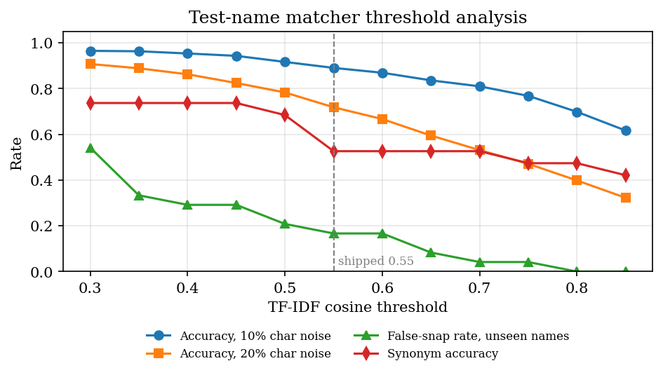
Figure 2: Name-matcher accuracy, false-snap rate and synonym accuracy against the similarity threshold
The method was kept because it needs no training data, is fast (about 0.6 ms per row) and handles inserted, missing and substituted letters; its documented weaknesses are abbreviations and synonyms ("Hb", "TLC", "LDL" are not matched at 0.55) and names that contain a dictionary name ("Sodium Bicarbonate" becomes "Sodium").

6.6 Result classification
Classification compares the value v with the reference limits ℓ (low) and h (high) printed on the same row, so the result follows the laboratory's own range for that patient and method instead of a generic table:
status(v) = LOW if v < ℓ; HIGH if v > h; NORMAL if ℓ ≤ v ≤ h; with only h: HIGH if v > h else NORMAL; with only ℓ: LOW if v < ℓ else NORMAL; with neither: UNKNOWN (4)
The bounds are inclusive. A value of exactly 5 or 10 against a range of 5 to 10 is NORMAL, and a missing value is UNKNOWN. The dashboard separately counts a result as critical when it is far outside its range, using a fixed heuristic:
critical = (LOW and v < 0.5 ℓ) or (HIGH and v > 1.5 h) (5)
This is a screening heuristic for ordering attention, not a clinical severity score, and the interface says so by phrasing the alert as results "far outside the reference range".

6.7 Explanation generation
For each LOW or HIGH row ai_insights.generate_insight returns an explanation, possible causes and a recommendation. The text comes from a curated knowledge base of 17 tests (TEST_KNOWLEDGE), each entry holding what the test measures and a sentence for a low and a high result, worded as "can generally be associated with". Tests outside the knowledge base get a generic sentence ("a number of general, non-specific causes"). The recommendation is always the same sentence: discuss the result with a doctor, especially if it is far outside the range, if there are symptoms or if it is a new change. The design rules are written into the module header: never diagnose, never say a value confirms a condition, always show the disclaimer.
An optional second path rewrites the explanation in friendlier wording. When the use_llm switch is on and ANTHROPIC_API_KEY is set, the Anthropic Messages API [23] is called with the configured model identifier and a limit of 300 output tokens, with a prompt that asks for 3 to 4 plain sentences, forbids diagnosis and forbids new medical facts. Any exception, including a missing key, an outage or an empty reply, silently keeps the rule-based text, so the report never fails because of the language model. No key was available during development, so this path was not executed or measured.
Coverage is limited: the knowledge base covers 17 of the 55 dictionary tests (30.9%); in the evaluation corpus 202 of 565 abnormal dictionary rows (35.8%) received test-specific text and the rest the generic sentence.
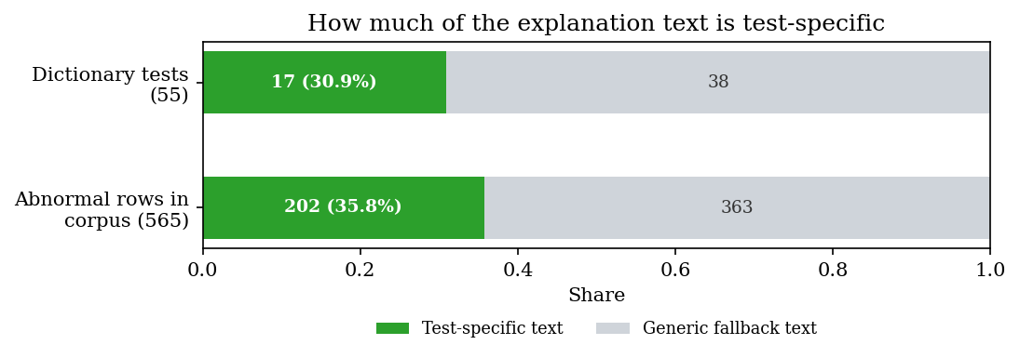
Figure 3: Share of abnormal rows that received test-specific explanation text

6.8 Choices against the project abstract
The abstract proposed PP-OCR, a conditional random field tagger and retrieval-augmented generation [1], [6], [12], [14]. The delivered system uses simpler components, and the reasons and the cost are stated here.
Table 5: Proposed components and what was built
Proposed in the abstract | Built | Reason | Consequence
PP-OCR text extraction [12] | PyMuPDF text layer, with OpenCV and Tesseract for scans | Digital PDFs need no OCR; Tesseract is free, widely available and has a Python wrapper | Scanned-image accuracy not measured; PP-OCR is untested here
CRF-based named-entity tagging [14] | Regular-expression row parser and TF-IDF name matcher | No labelled lab-report corpus existed to train a tagger; the rows are tabular, so patterns are exact and inspectable | Fails on layouts the patterns do not cover (cell-per-line tables score 0)
Retrieval-augmented explanations from trusted sources [1], [6] | Curated rule-based text, optional LLM rewording | A small vetted text is safer than free generation for health content and works offline | No retrieval and no citations; 31 % of dictionary tests have specific text
Supabase (PostgreSQL, row-level security) | SQLite through SQLAlchemy [19] | Zero set-up for a local demonstration | No per-user isolation
Serverless Cloud Functions | FastAPI [21] on one process | Runs on a laptop; same code can later be containerised | Not deployed to a cloud
React, Tailwind CSS, Recharts | React, hand-written CSS kit, Recharts [22] | A design kit gave consistent theming without a utility framework | Tailwind not used

On the generated corpus the delivered parser reaches a row precision of 0.963, a recall of 0.874 and an F1 of 0.916; Chapter 8 breaks this down by layout and field.

2. NOVELTY AGAINST THE BASE PAPER
The base paper [1] is a retrieval-augmented question-answering assistant for one condition. This project is a different kind of system, so the comparison is about scope and evidence, not about a better score on a shared benchmark. No benchmark is shared.
Table 6: Base paper and this project
Aspect | Base paper | LabLens
Purpose | advice on metabolic syndrome from a blood report | a general reader for any laboratory report: extract, flag, explain, store, track
Parameters | 33 fixed metabolic-syndrome parameters | any name value unit range row; a 55-name dictionary only normalises spelling
Explanation engine | LLaMA-3 8B with retrieval over books and transcripts | curated rules, optional LLM rewrite; deterministic by default and never diagnostic
Memory across reports | stored reports are consulted in later queries; trends are future scope | per-test trend chart against the reference band and two-report comparison
Evidence | 20 responses rated by GPT-4 | 1,680 labelled rows in 120 generated reports, 20,000 classification cases, 36 tests, latency

What is new
• Breadth of input. The base paper's system answers about 33 chosen parameters. LabLens reads whatever rows a report contains, keeps tests it does not know under the name printed, and snaps only close spellings.
• Longitudinal use. Results are stored per report and organised by test, so a user sees a value against its reference band over time and compares two reports.
• A measured extraction stage. The base paper does not report extraction accuracy. Here the extraction is scored on a labelled corpus, per layout and per field, with its failures listed.
• Conservative explanation design. Every explanation is general, framed as possible causes, ends with a suggestion to see a professional and cannot be produced without the disclaimer.

What is not new
None of the individual techniques is original: PDF text-layer reading [20], Tesseract OCR [13], regular-expression line parsing, TF-IDF vectors [15] with cosine similarity [16], threshold rules, a SQL store [19] and a REST service [21] are all standard. The abstract's PP-OCR [12], CRF tagging [14] and retrieval-augmented generation [6] would be the more current techniques; they were not built, and Chapter 8 shows where that costs accuracy (names, units and unseen tests). The contribution is the integration, the longitudinal feature set and the honest measurement.

3. KEY CONTRIBUTIONS
The contributions below are stated with the evidence that supports each; none is a claim of state-of-the-art performance.
1. An end-to-end pipeline from an uploaded report to extracted, classified, explained, stored and trended results, in which the LOW / NORMAL / HIGH rule agreed with an independent reference rule on 20,000 random cases.
2. A dictionary-snapping name matcher built on TF-IDF character n-grams, analysed with a noise sweep and a threshold sweep that expose its trade-offs.
3. A rule-based explanation module with a medical disclaimer on every output, an optional LLM rewrite and a silent fall-back to the built-in text.
4. Longitudinal features that the base paper lacks: per-test trends against the reference band, side-by-side comparison of two reports, a dashboard and an insights page, demonstrated on five synthetic reports sent through the real pipeline.
5. A measurement harness: a generated corpus of 120 reports in eight layouts, extraction, name-noise and latency experiments, and 36 pytest tests plus a 31-check smoke test, with the failures reported rather than hidden.

